Test Case: tc002_SPX_Dev5_Crear_Requisicion_Spot_Con_FAD_Tipo_Cobro_CC
Step 1 - Enter username and password and click to button Enter : Credentials Entered
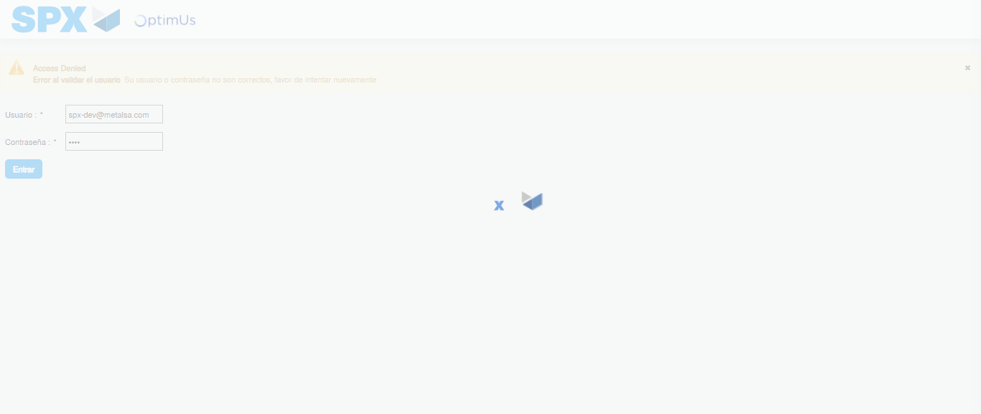Image file-name: QC_Testing-tc002_SPX_Dev5_Crear_Requisicion_Spot_Con_FAD_Tipo_Cobro_CC-1783355310702

Step 2 - Select to UEN and Access to Spot Buy Requisitions : UEN Correctly selected and Correct access
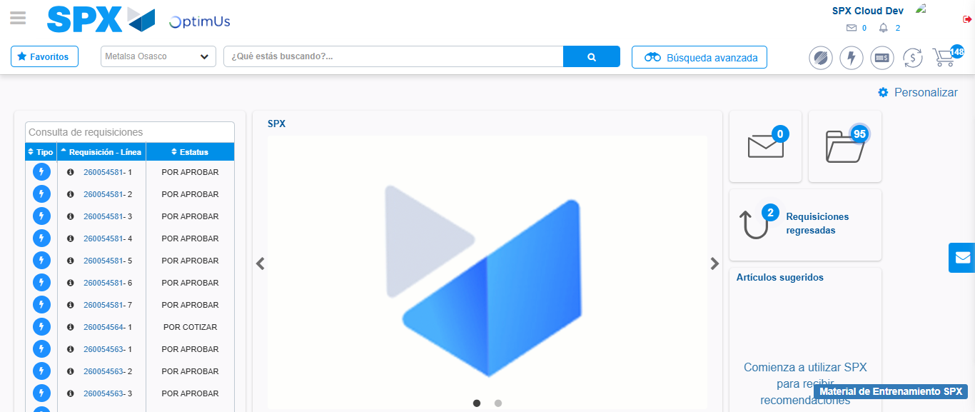Image file-name: QC_Testing-tc002_SPX_Dev5_Crear_Requisicion_Spot_Con_FAD_Tipo_Cobro_CC-1783355336457

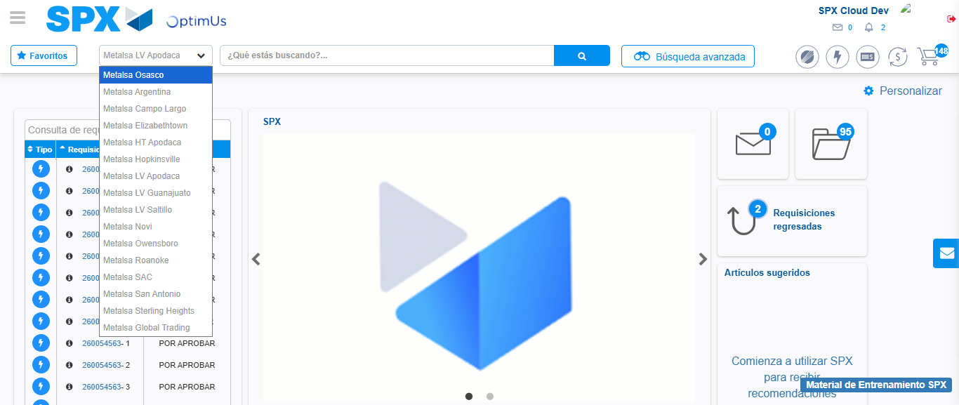Image file-name: QC_Testing-tc002_SPX_Dev5_Crear_Requisicion_Spot_Con_FAD_Tipo_Cobro_CC-1783355339063

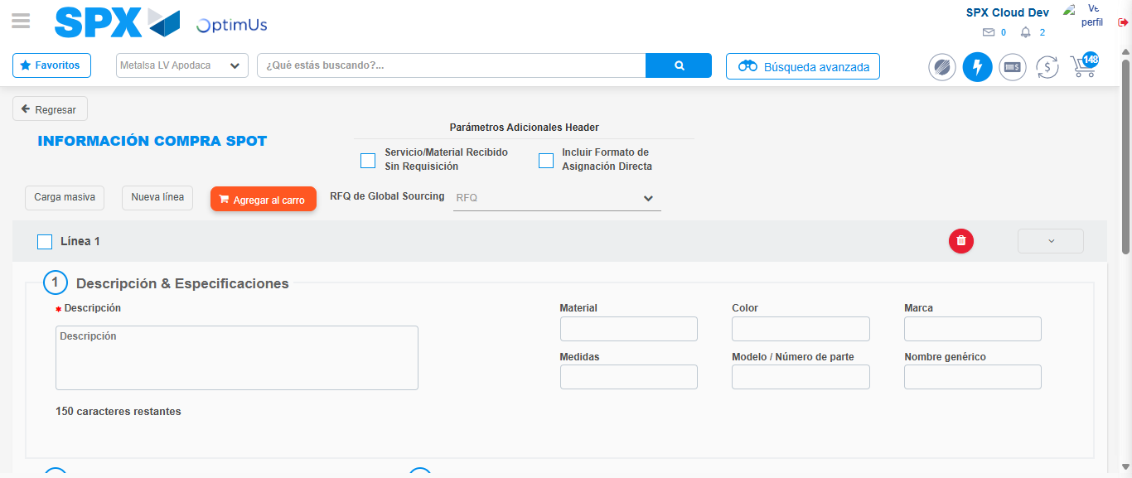Image file-name: QC_Testing-tc002_SPX_Dev5_Crear_Requisicion_Spot_Con_FAD_Tipo_Cobro_CC-1783355359771

Step 3 - Add FAD to Requisition: FAD Successfully Added
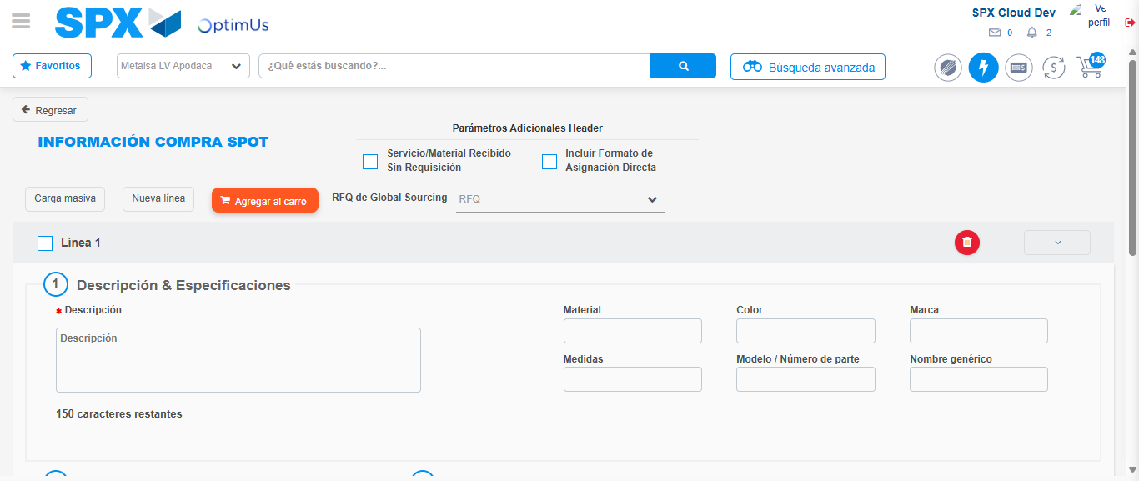Image file-name: QC_Testing-tc002_SPX_Dev5_Crear_Requisicion_Spot_Con_FAD_Tipo_Cobro_CC-1783355359977

Image file-name: QC_Testing-tc002_SPX_Dev5_Crear_Requisicion_Spot_Con_FAD_Tipo_Cobro_CC-1783355360119

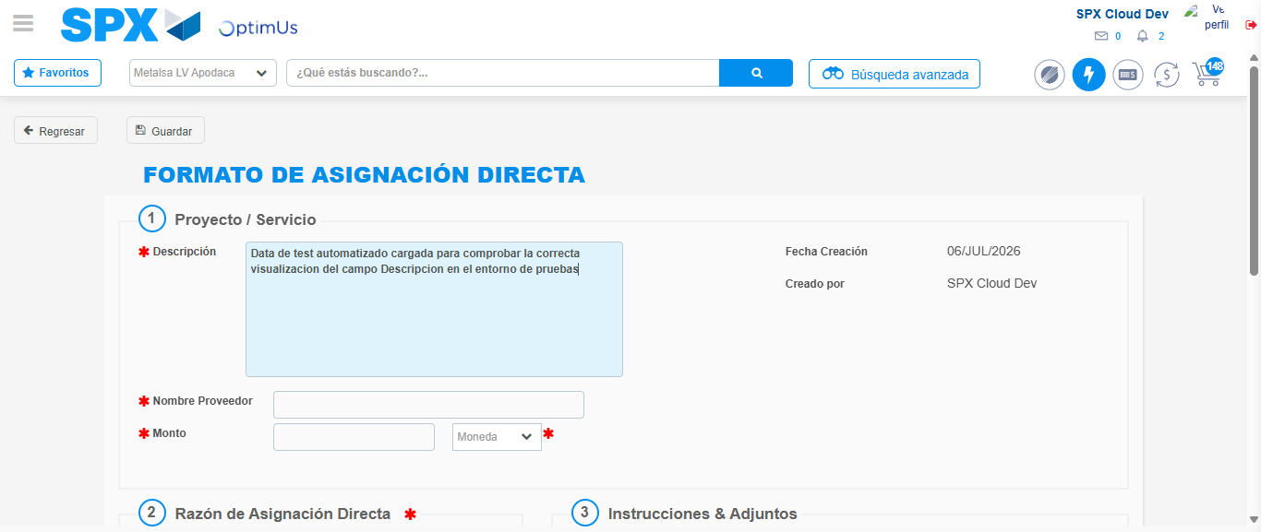Image file-name: QC_Testing-tc002_SPX_Dev5_Crear_Requisicion_Spot_Con_FAD_Tipo_Cobro_CC-1783355362957

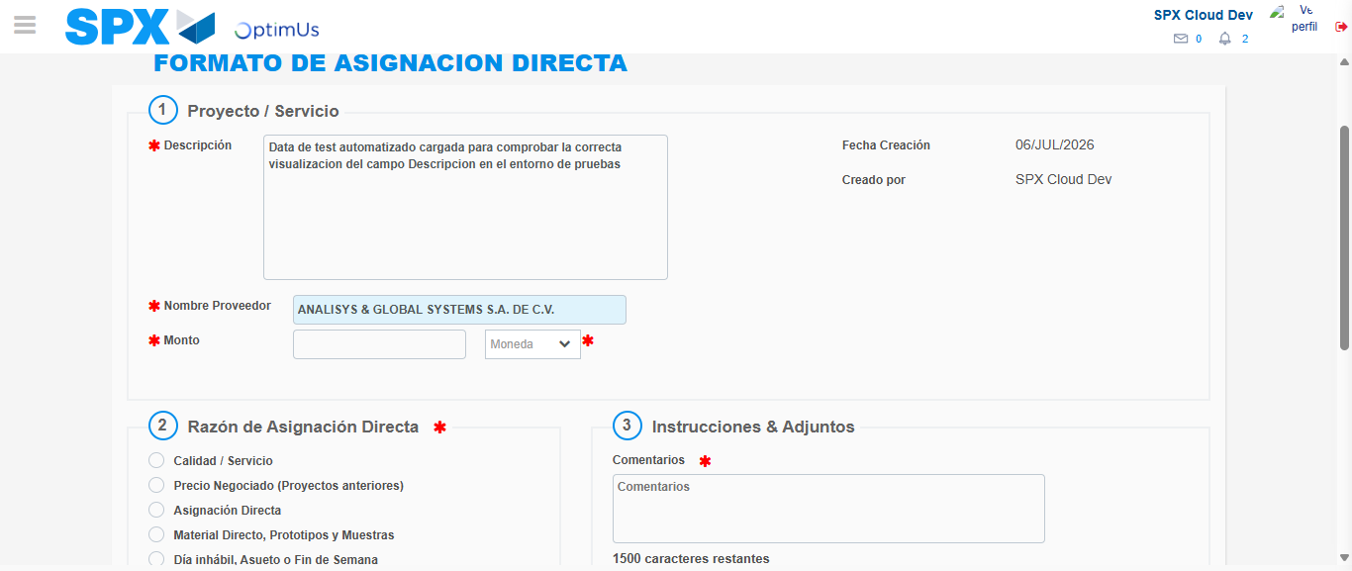Image file-name: QC_Testing-tc002_SPX_Dev5_Crear_Requisicion_Spot_Con_FAD_Tipo_Cobro_CC-1783355368754

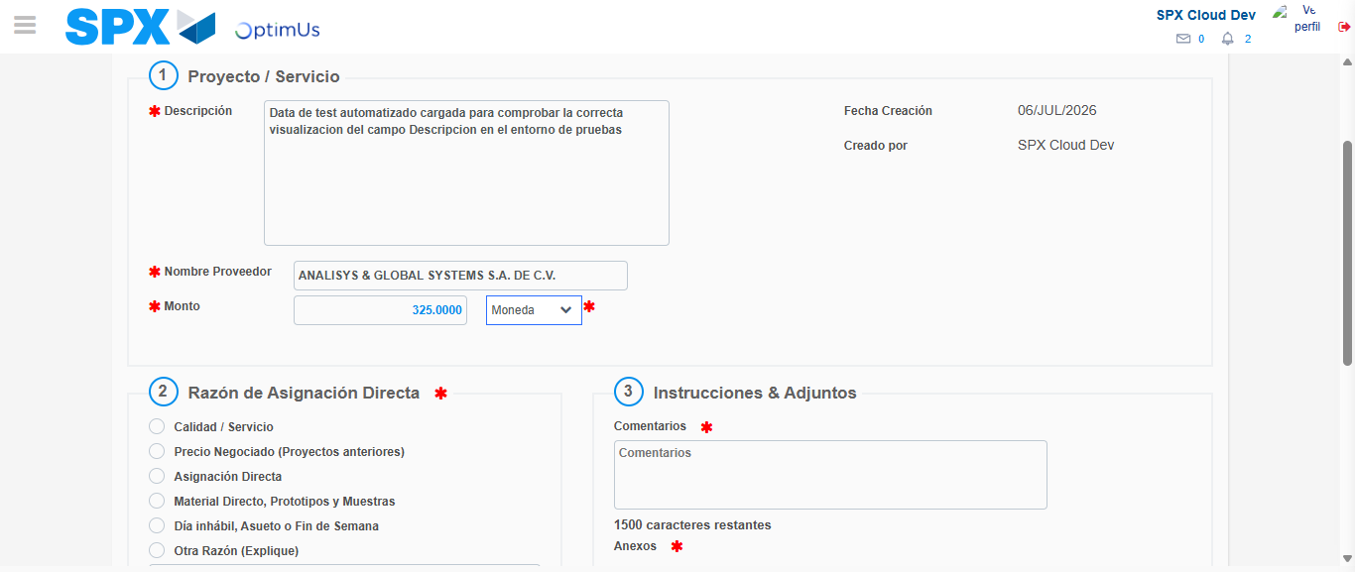Image file-name: QC_Testing-tc002_SPX_Dev5_Crear_Requisicion_Spot_Con_FAD_Tipo_Cobro_CC-1783355369217

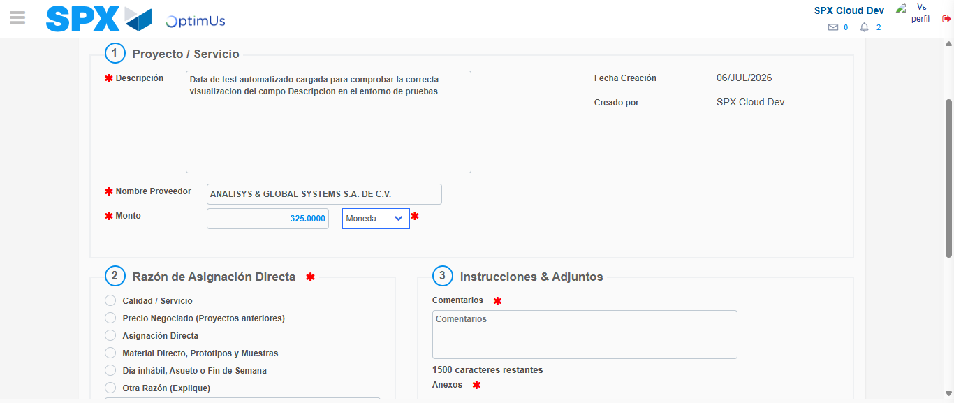Image file-name: QC_Testing-tc002_SPX_Dev5_Crear_Requisicion_Spot_Con_FAD_Tipo_Cobro_CC-1783355369411

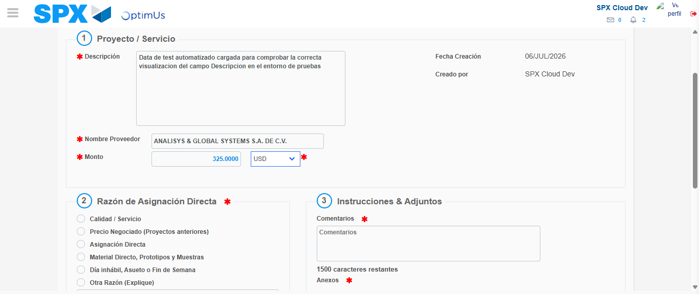Image file-name: QC_Testing-tc002_SPX_Dev5_Crear_Requisicion_Spot_Con_FAD_Tipo_Cobro_CC-1783355369730

Image file-name: QC_Testing-tc002_SPX_Dev5_Crear_Requisicion_Spot_Con_FAD_Tipo_Cobro_CC-1783355369930

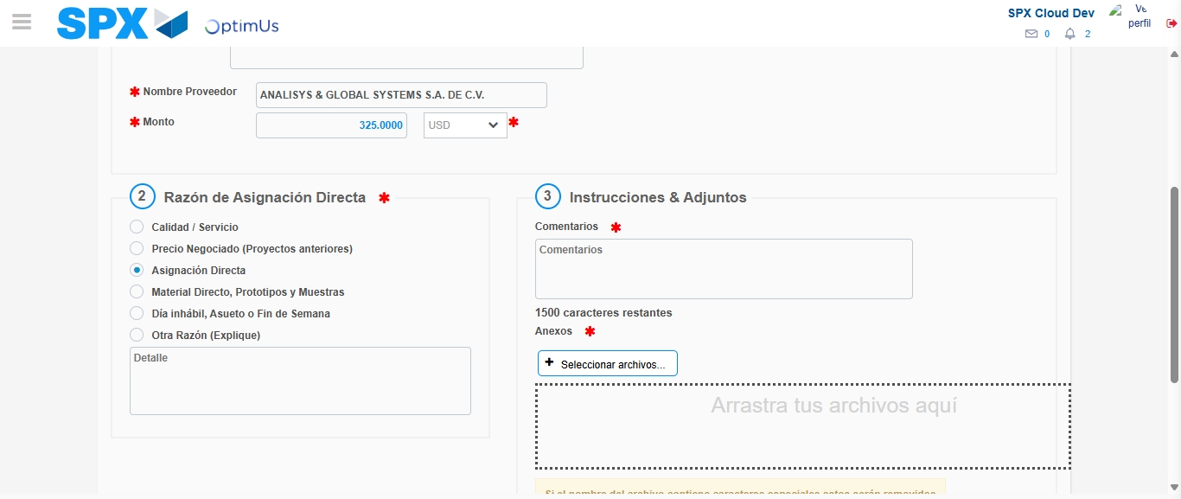Image file-name: QC_Testing-tc002_SPX_Dev5_Crear_Requisicion_Spot_Con_FAD_Tipo_Cobro_CC-1783355370776

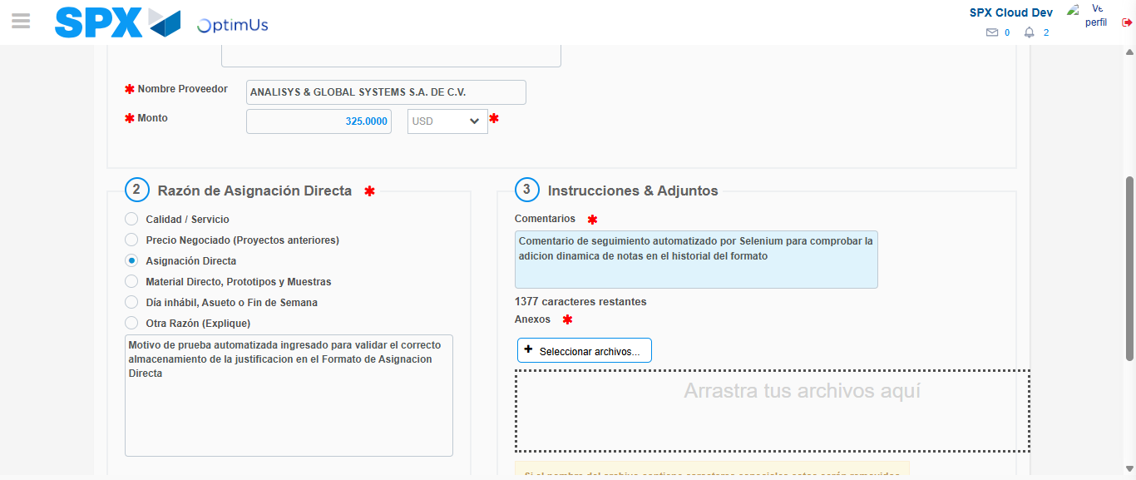Image file-name: QC_Testing-tc002_SPX_Dev5_Crear_Requisicion_Spot_Con_FAD_Tipo_Cobro_CC-1783355381765

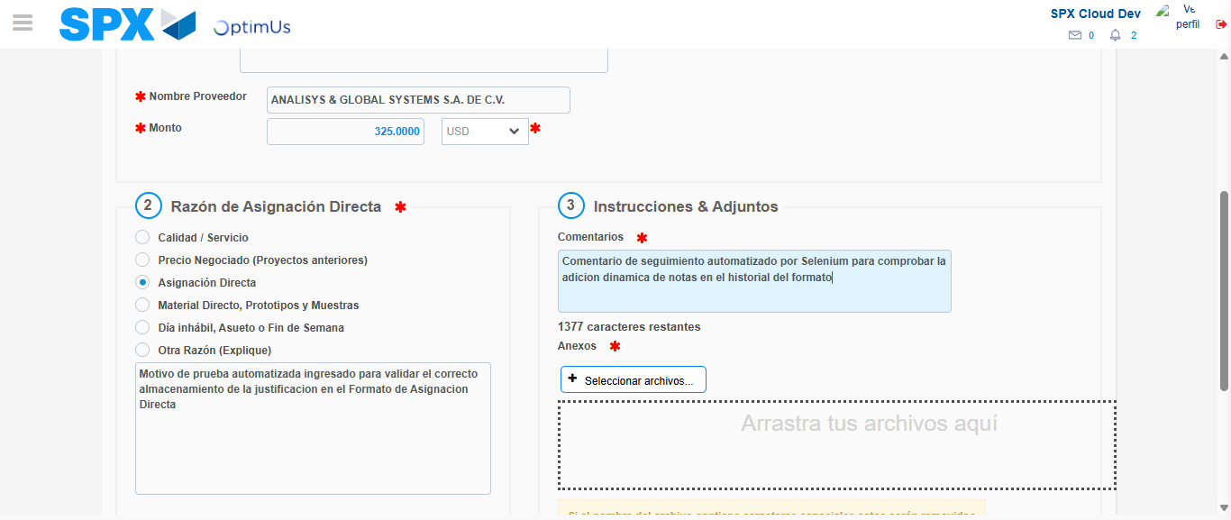Image file-name: QC_Testing-tc002_SPX_Dev5_Crear_Requisicion_Spot_Con_FAD_Tipo_Cobro_CC-1783355382407

Step 4 - Data Capture Spot Buy Requisition: Data captured correctly
Image file-name: QC_Testing-tc002_SPX_Dev5_Crear_Requisicion_Spot_Con_FAD_Tipo_Cobro_CC-1783355359977

Image file-name: QC_Testing-tc002_SPX_Dev5_Crear_Requisicion_Spot_Con_FAD_Tipo_Cobro_CC-1783355360119

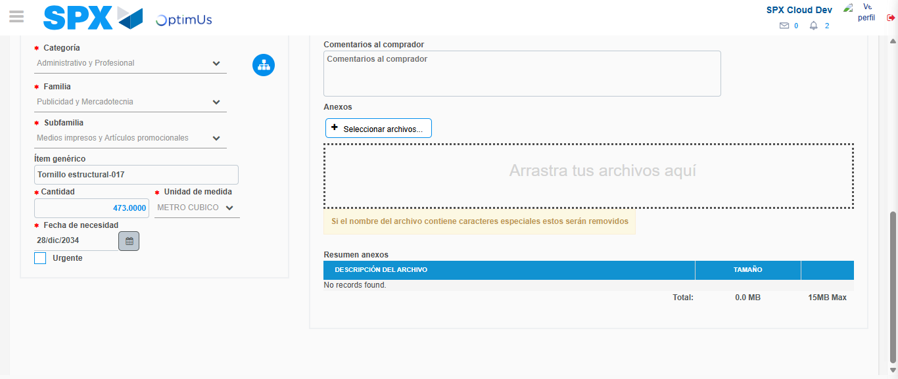Image file-name: QC_Testing-tc002_SPX_Dev5_Crear_Requisicion_Spot_Con_FAD_Tipo_Cobro_CC-1783355392062

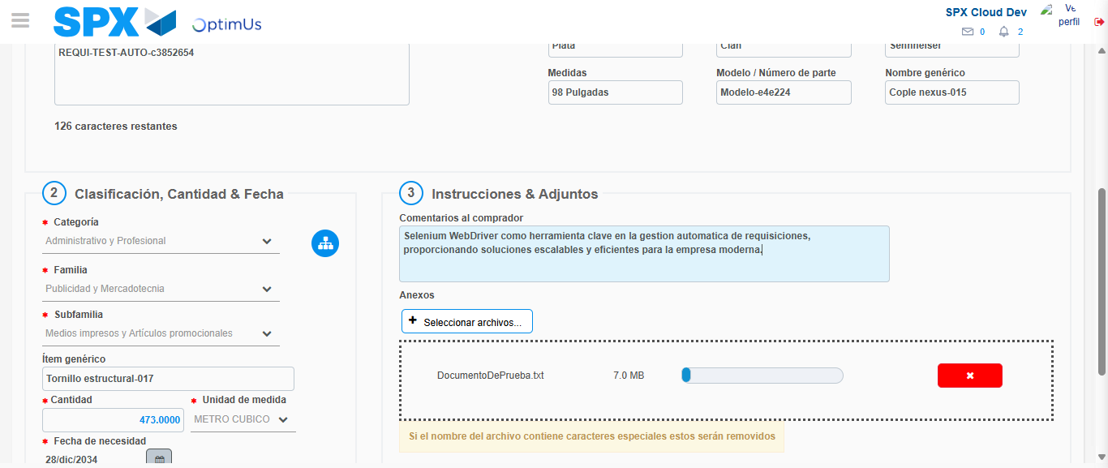Image file-name: QC_Testing-tc002_SPX_Dev5_Crear_Requisicion_Spot_Con_FAD_Tipo_Cobro_CC-1783355392802

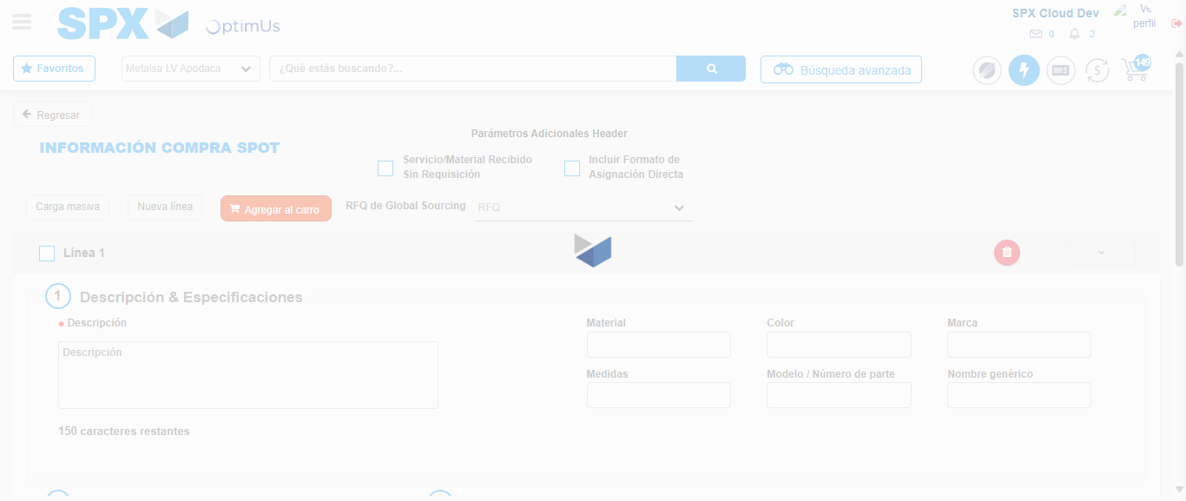Image file-name: QC_Testing-tc002_SPX_Dev5_Crear_Requisicion_Spot_Con_FAD_Tipo_Cobro_CC-1783355400225

Step 8 - Return to Main Page SPX : Return to Main Page SPX
Image file-name: QC_Testing-tc002_SPX_Dev5_Crear_Requisicion_Spot_Con_FAD_Tipo_Cobro_CC-1783355336457

Image file-name: QC_Testing-tc002_SPX_Dev5_Crear_Requisicion_Spot_Con_FAD_Tipo_Cobro_CC-1783355339063

Image file-name: QC_Testing-tc002_SPX_Dev5_Crear_Requisicion_Spot_Con_FAD_Tipo_Cobro_CC-1783355359771

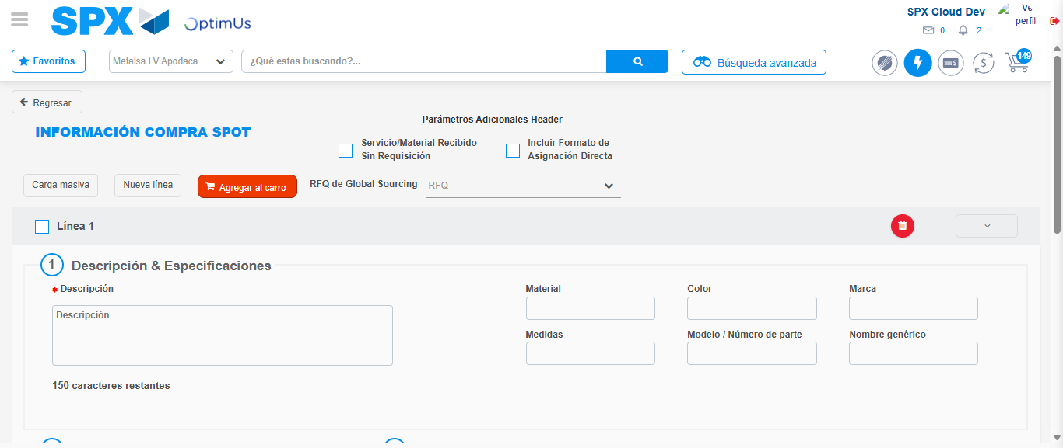Image file-name: QC_Testing-tc002_SPX_Dev5_Crear_Requisicion_Spot_Con_FAD_Tipo_Cobro_CC-1783355402467

Image file-name: QC_Testing-tc002_SPX_Dev5_Crear_Requisicion_Spot_Con_FAD_Tipo_Cobro_CC-1783355402662

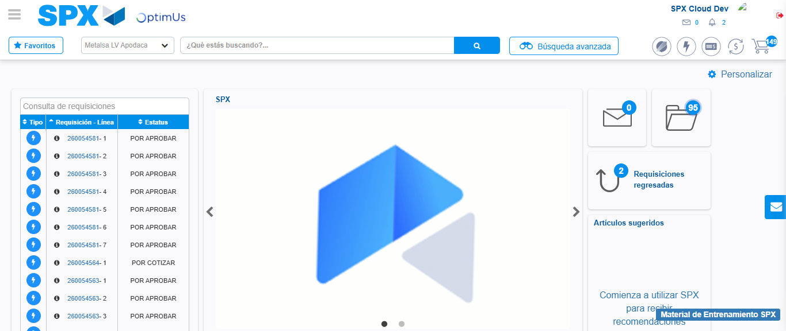Image file-name: QC_Testing-tc002_SPX_Dev5_Crear_Requisicion_Spot_Con_FAD_Tipo_Cobro_CC-1783355423820

Step 9 - Log Out : Log Out SPX
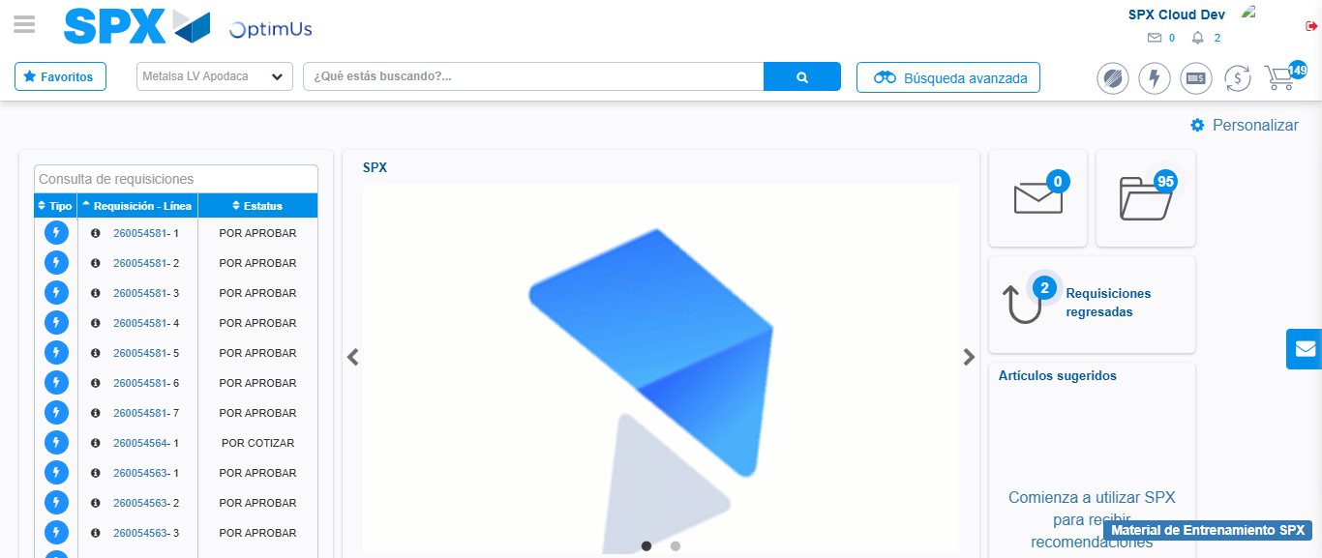Image file-name: QC_Testing-tc002_SPX_Dev5_Crear_Requisicion_Spot_Con_FAD_Tipo_Cobro_CC-1783355424161

